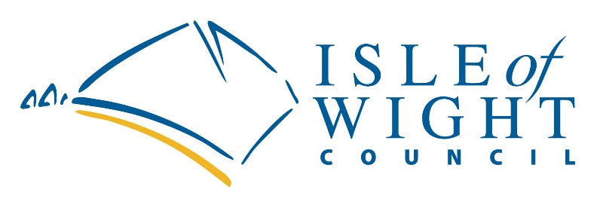

green homes supply chain grants
Application Form

Important – you must read the Green Homes Supply Chain Grants Guidance before filling out this form. There are specific criteria that you must meet to be eligible to apply for this fund.

Please check your details carefully as incorrect information will delay the assessment of your application.

Please ensure that any statements made in this application are true and based on firm evidence. Any application found to have used erroneous information will be declined. Any grant awarded that is subsequently found to be based on erroneous information will be reclaimed from the applicant, through legal means if necessary.

ALL SECTIONS MUST BE COMPLETED (please enter 'N/A' only if section is not applicable to your business). Please submit this application form and supporting documents in Microsoft Word and/or PDF formats.

Completed application forms should be submitted to GHGLAD@iow.gov.uk

CLOSING DATE: 23.59 on Sunday 19th September 2021

Applicant details
Applicant Name | Click or tap here to enter text.
Business Name | Click or tap here to enter text.
Business Trading Address  (full address including postcode) | Click or tap here to enter text.
Contact email | Click or tap here to enter text.
Contact phone number | Click or tap here to enter text.
Company Reference Number (CRN)  (If sole trader, please provide Unique Taxpayer Reference) | Click or tap here to enter text.
Date of Business established | Click or tap here to enter text.
Business Details
Number of employees (full time equivalents) | Click or tap here to enter text.
Turnover last financial year | Click or tap here to enter text.
Is your business in administration, insolvent or has a striking-off notice been made. | Click or tap here to enter text.
What are your current business activities (max 200 words)?
Click or tap here to enter text.

How do you intend to be involved in the energy efficiency sector in the future (max 300 words)?
Click or tap here to enter text.

Please describe your need for a grant and what you intend to do with the funding. Please include timescales (max 500 words).
Click or tap here to enter text.

How much funding do you require (max 50% of eligible costs)?

Amount of funding required £ Click or tap here to enter text.
Match funding provided £ Click or tap here to enter text.

Please explain how the match funding will be provided and whether this is cash or in-kind
Click or tap here to enter text.

State Aid
During the last 3 years, have you received any financial help from a public body?
Yes ☐/ No ☐

If the answer is yes, please detail below with the source of the funds, the date it was received, and the amount awarded.
Click or tap here to enter text.

Declaration

I certify that all the statements above are true to the best of my knowledge and that I will immediately inform the council of any change in circumstances with my business. I understand that if any of the above is proved to be false then any grant application is null and void and the council will seek repayment of any monies awarded.
Signed Date Click or tap to enter a date.

An electronic signature is allowable. Alternatively print the form, sign and send a scanned copy.
Please return the form by email to along with any supporting evidence to GHGLAD@iow.gov.uk . Complete evidence will allow us to process an application quicker – please take care how you fill in the form and in the evidence you provide. PLEASE NOTE all applications should be submitted electronically

Any queries on the form, please email ecdev@iow.gov.uk please include a phone number on any email as this may help your enquiry being resolved.

GDPR Statement

The Isle of Wight Council is the data controller for the personal information you provide on this form. The council’s Data Protection Officer can be contacted at dpo@iow.gov.uk. You can contact the council by phone on 01983 821000, or by writing to us at County Hall, High Street, Newport, Isle of Wight, PO30 1UD.

Your information is required so that we can administer your grant claim and provide you with any funding awarded. By submitting your claim you are consenting to the processing of your application, but you may withdraw your consent at any time. If you subsequently withdraw your consent, we may not be able to process your claim.

The data collected in this form will be used by Economic Development and the Payments Team. We will keep your personal data in accordance with our Retention Policy which is available on our website.

Further details about your rights can be found on our website at
- https://www.iow.gov.uk/Council/OtherServices/Website/Privacy

