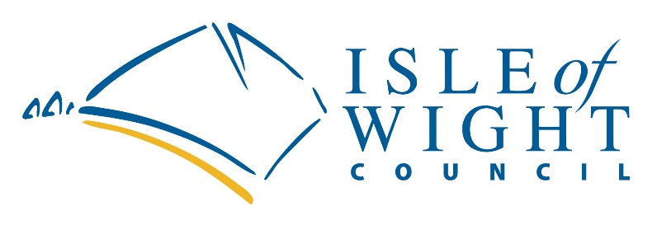
OMICRON ARG 2022 (Discretionary) Funding
GUIDANCE

Introduction

In response to the rise of the Omicron variant in December 2021 the chancellor announced a further £1b funding package for business grant support to be provided via local authorities to help small businesses, particularly those in the hospitality and leisure sector including accommodation providers. The new Omicron support has two elements:

- The Omicron Hospitality and Leisure Grant (OHLG) which is for those operating from business rated premises in the hospitality, leisure and accommodation sectors (as defined in the detailed government guidance) and is grant based on their rateable value.
- New Additional Restrictions Grant 2022 (ARG) which is further discretionary funding to support companies severely impacted by Covid and the rise of the Omicron variant.

This guidance is for the new ARG 2022 scheme ONLY. Guidance detailing eligibility criteria for OHLG can be viewed via the following LINK.

Applications for this new ARG 2022 funding will close at 23.59 on Monday 14 February 2022.

Criteria

These will be applied to all applications. Applications can only come from the following:

1. Small and micro businesses, as defined in Section 33 Part 2 of the Small Business, Enterprise and Employment Act 2015 and the Companies Act 2006 unless specified in the grant category.
  - To be a small business, under the Companies Act 2006, a business must satisfy two or more of the following requirements in a year—
    - Turnover: Not more than £10.2 million
    - Balance sheet total: Not more than 5.1 million
    - Number of employees: a headcount of staff of less than 50
  - To be a micro business, under the Companies Act 2006, a business must satisfy two or more of the following requirements—
    - Turnover: Not more than £632,000
    - Balance sheet total: Not more than £316,000
    - Number of employees: a headcount of staff of not more than 10
In exceptional circumstances, business who exceed these criteria will be considered under the following circumstances:
  - The company has been severely financially affected by the current restrictions.
  - Its’ principal base of operation is the Isle of Wight
  - It doesn’t employ more than 250 employees (FTEs)

2. Businesses which do not pay business rates which can demonstrate a significant impact on their business as a result of the rise of the omicron variant.

3. The business needs to be solvent and operational on Wednesday 5 January 2022.

To clarify – the form asks if you were operational on Wednesday 5 January 2022. To be operational, a business should be able to trade on that day – for example a shop was open. Please see additional information at Appendix 1.

Businesses who have previously applied for the Coronavirus Job Retention Scheme and the Self Employment Income Support Scheme are eligible to apply for this scheme.

Companies that are in administration, are insolvent or where a striking-off notice has been made are not eligible for funding under this scheme.

Businesses will be able to apply for a grant which will be considered on the strength of the application and the evidence provided. Awards will be made in light of the number and range of applications made relative to the grant money provided by central government to the council. All decisions on grant applications received will be made after the closing date of Monday 14 February 2022. This is to allow awards to be made in recognition of the limited funds available.

It is important to stress that businesses will need to evidence they were solvent on Wednesday 5 January 2022 and that they can demonstrate with submitted evidence that they have been specifically impacted since December 2021 by the rise of the Omicron variant.

Grant Process

PLEASE NOTE – APPLICATIONS FOR THIS FUNDING WILL CLOSE ON MONDAY 14 FEBRUARY 2022

- This guidance is available as a downloadable document on the council’s website.
- The council can only accept applications made online HERE and cannot accept email or paper copies.
- The scheme will run until 23.59 on Monday 14 February 2022. ALL applications will be considered once the deadline closed on the basis of the information provided.
- All applications will be evaluated and determined by the Island's Economic Development Board.
- Applicants will be advised of the decision via email. (Please add ecdev@iow.gov.uk to your contacts)
- Should an applicant be unsuccessful, they may appeal to the Director of Regeneration who in consultation with the Cabinet member for Regeneration and Business will consider and determine the appeal. Their decision is final.
- Successful applicants will receive payment through the normal council payment channels.
- Applicants are reminded that the grant is taxable and should be declared.

Please note that you will be required to provide evidence of bank statement dated within the last 3 months (transaction details can be redacted) but all other information matching the information provided must be shown – specifically the name on the bank account, the account holder’s address and the account details such as sort code and account number. This is to enable the Council to undertake mandatory fraud checks which the government have insisted on as part of the conditions of the council receiving and distributing the funding.

For the purposes of debt recovery and fraud prevention there is the potential need to share your data with other government departments and private agencies.

Appendix 1

What constitutes trading?

For the purposes of this scheme, a business is considered to be trading if it is engaged in business activity. This should be interpreted as carrying on a trade or profession, or buying and selling goods or services in order to generate turnover. Fully constituted businesses in liquidation, dissolved, struck off or subject to a striking-off notice are not eligible under these conditions.

To help further, some trading indicators are included below that can help assess what can be defined as trading for the purposes of this scheme. Indicators that a business is trading are:

- The business continues to trade online, via click and collect services etc.
- The business is not in liquidation, dissolved, struck off or subject to a striking-off notice or under notice.
- The business is engaged in business activity; managing accounts, preparing for reopening, planning and implementing COVID-safe measures.

